***File Upload code***

**FileUploadDao.java**

**package** com.parkingportalmain.dao;

**import** java.io.InputStream;

**import** java.sql.Blob;

**import** java.sql.Connection;

**import** java.sql.DriverManager;

**import** java.sql.PreparedStatement;

**import** java.sql.SQLException;

**public** **class** FileUploadDao {

**private** **static** **final** String ***url*** = "jdbc:mysql://localhost:3306/parkingportal?useSSL=false";

**private** **static** **final** String ***user*** = "root";

**private** **static** **final** String ***password*** = "Intern@1234";

**private** **static** **final** String ***sql*** = "INSERT INTO adamscitylights (registrationv1doc, insurancev1doc, registrationv2doc, insurancev2doc) values (?, ?, ?, ?)";

**public** **int** uploadFile(Blob registrationv1doc, Blob insurancev1doc, Blob registrationv2doc, Blob insurancev2doc) {

**int** row = 0;

**try** {

Class.*forName*("com.mysql.cj.jdbc.Driver");

} **catch** (ClassNotFoundException e1) {

e1.printStackTrace();

}

**try** (Connection connection = DriverManager.*getConnection*(***url***, ***user***, ***password***);

PreparedStatement preparedStatement = connection.prepareStatement(***sql***)) {

**if** (registrationv1doc != **null**) {

preparedStatement.setBlob(1, registrationv1doc);

} **else** {

preparedStatement.setNull(1, java.sql.Types.***BLOB***);

}

**if** (insurancev1doc != **null**) {

preparedStatement.setBlob(2, insurancev1doc);

} **else** {

preparedStatement.setNull(2, java.sql.Types.***BLOB***);

}

**if** (registrationv2doc != **null**) {

preparedStatement.setBlob(3, registrationv2doc);

} **else** {

preparedStatement.setNull(3, java.sql.Types.***BLOB***);

}

**if** (insurancev2doc != **null**) {

preparedStatement.setBlob(4, insurancev2doc);

} **else** {

preparedStatement.setNull(4, java.sql.Types.***BLOB***);

}

row = preparedStatement.executeUpdate();

} **catch** (SQLException e) {

printSQLException(e);

}

**return** row;

}

**private** **void** printSQLException(SQLException ex) {

**for** (Throwable e: ex) {

**if** (e **instanceof** SQLException) {

e.printStackTrace(System.***err***);

System.***err***.println("SQLState: " + ((SQLException) e).getSQLState());

System.***err***.println("Error Code: " + ((SQLException) e).getErrorCode());

System.***err***.println("Message: " + e.getMessage());

Throwable t = ex.getCause();

**while** (t != **null**) {

System.***out***.println("Cause: " + t);

t = t.getCause();

}

}

}

}

}

**FileUploadServlet.java**

**package** com.parkingportalmain.web;

**import** java.io.IOException;

**import** java.io.InputStream;

**import** java.sql.Blob;

**import** java.sql.SQLException;

**import** javax.servlet.ServletException;

**import** javax.servlet.annotation.MultipartConfig;

**import** javax.servlet.annotation.WebServlet;

**import** javax.servlet.http.HttpServlet;

**import** javax.servlet.http.HttpServletRequest;

**import** javax.servlet.http.HttpServletResponse;

**import** javax.servlet.http.Part;

**import** javax.sql.rowset.serial.SerialBlob;

**import** com.parkingportalmain.dao.FileUploadDao;

@WebServlet("/uploadServlet")

@MultipartConfig(maxFileSize = 16177215)

**public** **class** FileUploadServlet **extends** HttpServlet {

**private** **static** **final** **long** ***serialVersionUID*** = 1L;

**protected** **void** doPost(HttpServletRequest request, HttpServletResponse response)

**throws** ServletException, IOException {

// get form fields and files

InputStream registrationv1docInputStream = **null**;

InputStream insurancev1docInputStream = **null**;

InputStream registrationv2docInputStream = **null**;

InputStream insurancev2docInputStream = **null**;

Part registrationv1docPart = request.getPart("registrationv1doc");

Part insurancev1docPart = request.getPart("insurancev1doc");

Part registrationv2docPart = request.getPart("registrationv2doc");

Part insurancev2docPart = request.getPart("insurancev2doc");

**if** (registrationv1docPart != **null**) {

registrationv1docInputStream = registrationv1docPart.getInputStream();

}

**if** (insurancev1docPart != **null**) {

insurancev1docInputStream = insurancev1docPart.getInputStream();

}

**if** (registrationv2docPart != **null**) {

registrationv2docInputStream = registrationv2docPart.getInputStream();

}

**if** (insurancev2docPart != **null**) {

insurancev2docInputStream = insurancev2docPart.getInputStream();

}

// create BLOB objects from input streams

Blob registrationv1doc = **null**;

Blob insurancev1doc = **null**;

Blob registrationv2doc = **null**;

Blob insurancev2doc = **null**;

**try** {

**if** (registrationv1docInputStream != **null**) {

registrationv1doc = **new** SerialBlob(registrationv1docInputStream.readAllBytes());

}

**if** (insurancev1docInputStream != **null**) {

insurancev1doc = **new** SerialBlob(insurancev1docInputStream.readAllBytes());

}

**if** (registrationv2docInputStream != **null**) {

registrationv2doc = **new** SerialBlob(registrationv2docInputStream.readAllBytes());

}

**if** (insurancev2docInputStream != **null**) {

insurancev2doc = **new** SerialBlob(insurancev2docInputStream.readAllBytes());

}

} **catch** (SQLException e) {

e.printStackTrace();

}

// insert files into database

FileUploadDao fileUploadDao = **new** FileUploadDao();

**int** row = fileUploadDao.uploadFile(registrationv1doc, insurancev1doc, registrationv2doc, insurancev2doc);

**if** (row > 0) {

response.getWriter().write("File uploaded successfully.");

} **else** {

response.getWriter().write("File upload failed.");

}

}

}

Database

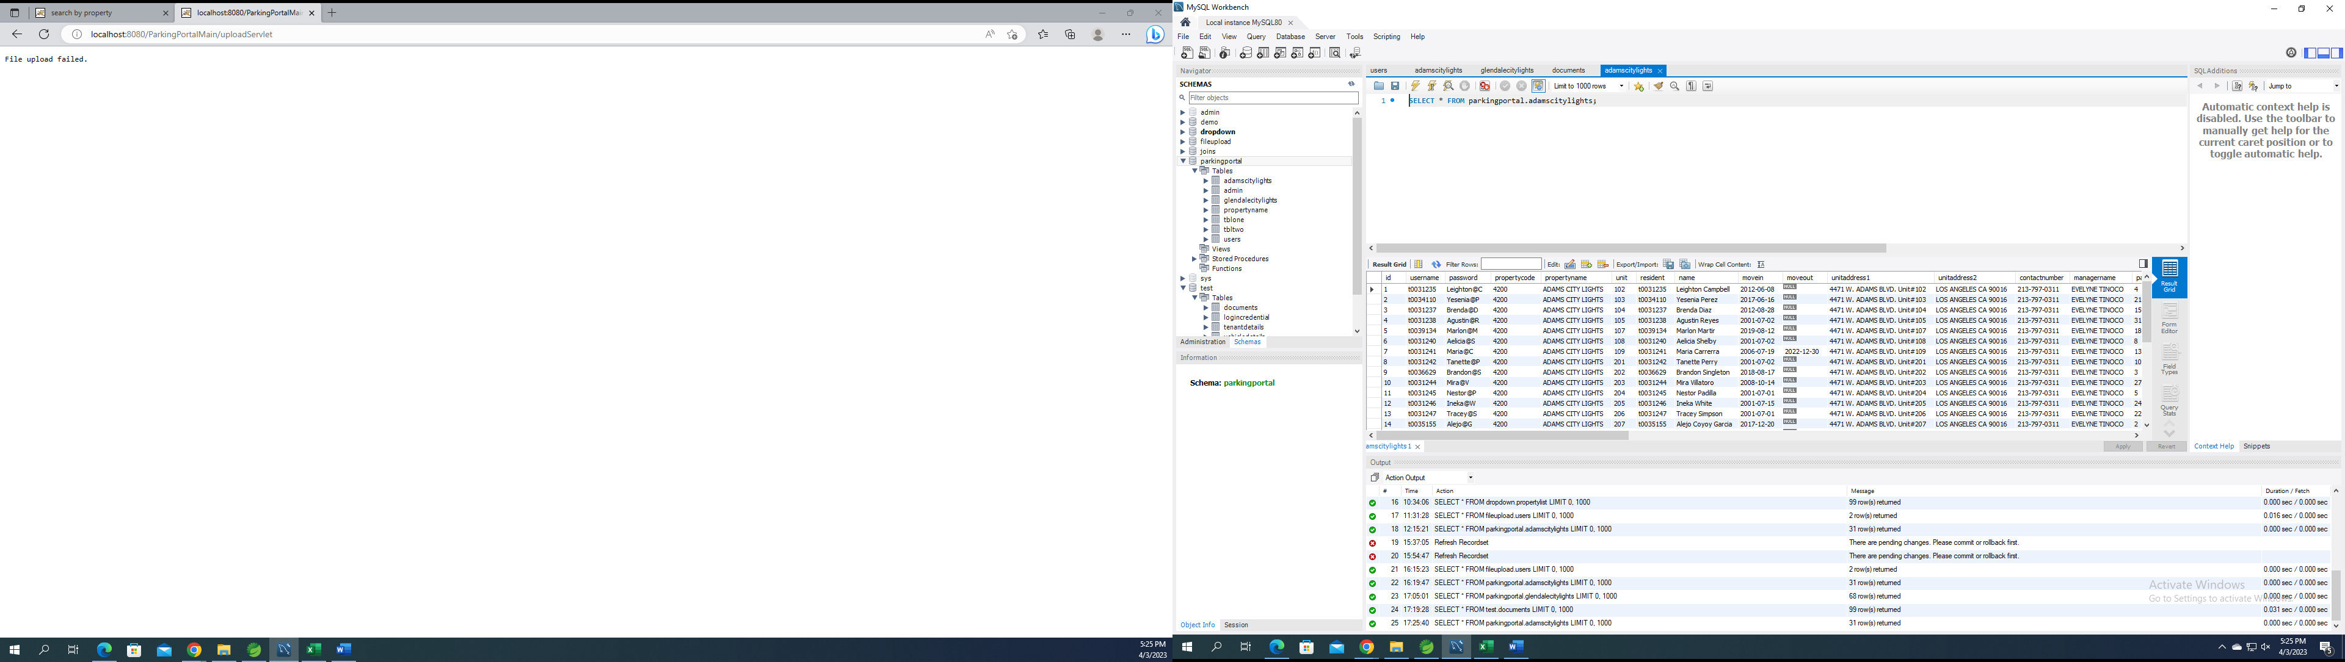

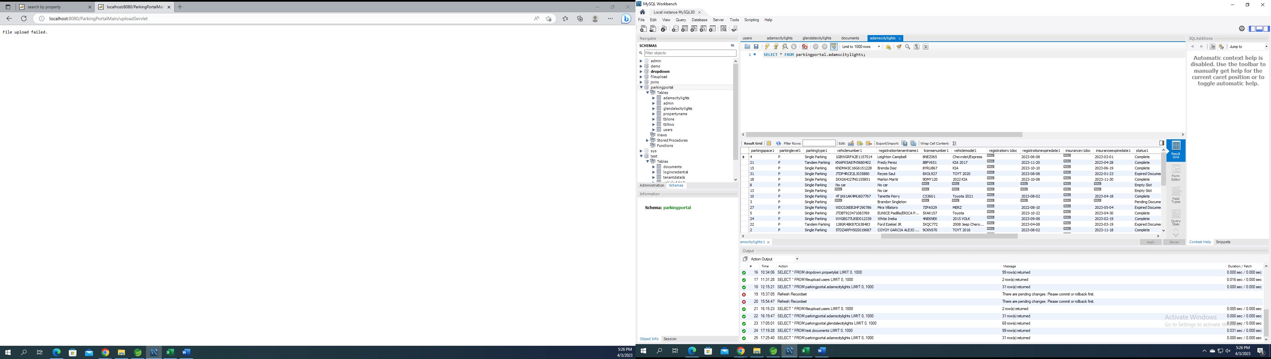

Firstpage

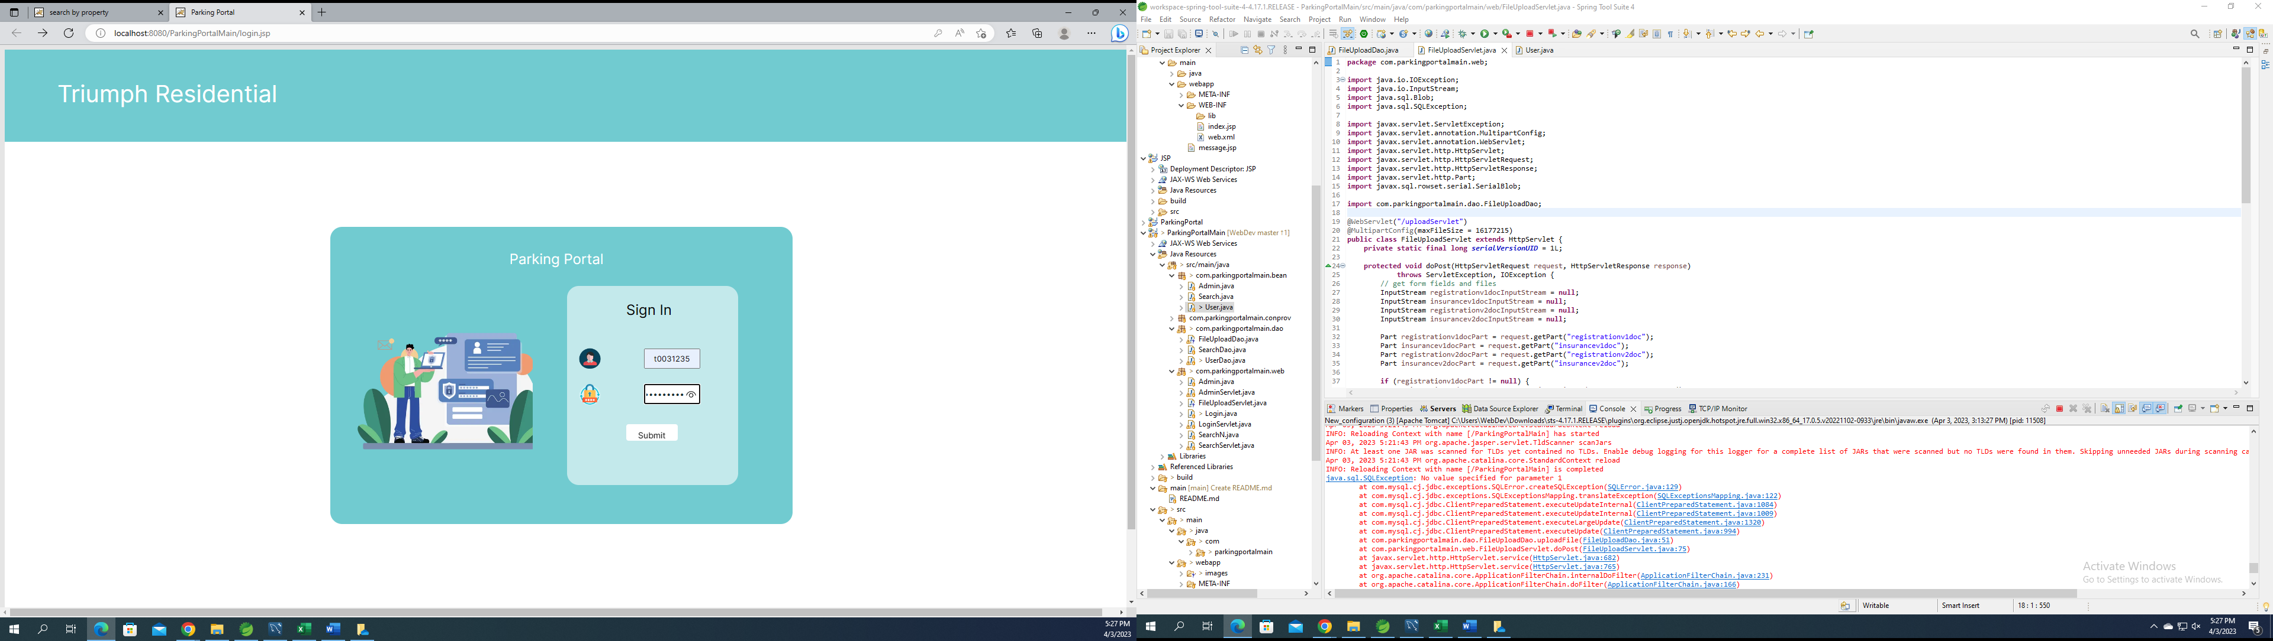

Secondpage

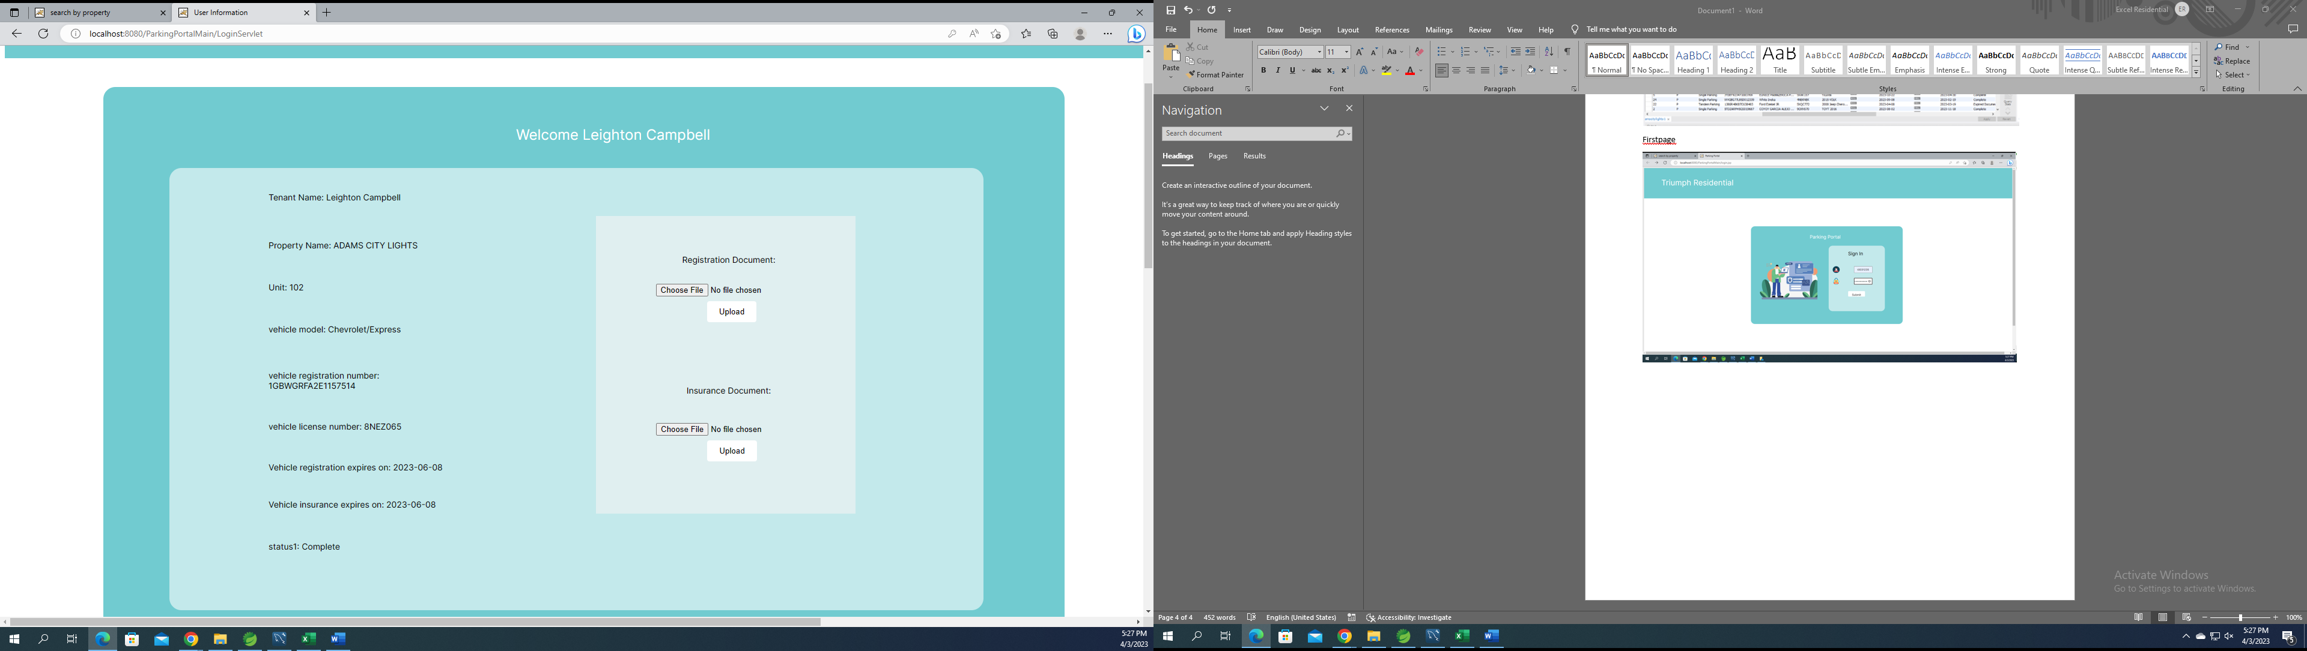

Error

